EVIDENCE
Guidepost 1: History is interpretation based on inferences made from primary sources. Primary sources can be accounts, but they can also be traces, relics, or records. | Guidepost 2: Asking good questions about a source can turn it into evidence. | Guidepost 3: Sourcing often begins before a source is read, with questions about who created it and when it was created. It involves inferring from the source the author’s purpose, values, worldview, either conscious or unconscious | Guidepost 4: A source should be analyzed in relation to the context of its historical setting: the conditions and worldviews prevalent at the time in question. | Guidepost 5 Inferences made from a source can never stand alone. They should always be corroborated-checked against other sources (primary or secondary)
Understands what inferences are | Understands the difference between an account and a trace | Understands what sourcing is | Understands what contextualizing is | Understands the difference between contrary, conflicting, complimentary, and corroborating primary sources
Understands that historians can draw different and even conflicting inferences from a source | Understands the difference between factual-recall questions, and open-ended inquiry questions | Identifies source metadata | Identifies relevant contextual information | Identifies when sources are contrary, conflicting, complimentary or corroborating.
Evaluates different inferences | Evaluates the suitability of questions about traces and accounts | Identifies / draws upon relevant metadata and background information to contextualize source. | Connects source to, and recognizes influence of, broader historical contexts on the content of a source | Corroborates evidence to support a claim / Uses multiple pieces of evidence in conjunction to support/discount a claim.
 | Generates relevant historical inquiry questions from a source | Evaluates the strengths and limitations of sources as evidence for a historical inquiry question |  | Uses source information, contextual information, and corroboration to evaluate and generate claims.

G1: Inference - Cognitive Demand: Understands what inferences are [Example]


Directions: After reading the background information and examining the source, answer the questions below.

Background Information: Prior to entering combat, Canadian and allied troops typically received their military training in Great Britain. The source below is a letter sent from Canadian Allan Hager to his sister on November 12th, 1915.
Dear Sister:

You'll excuse me if this letter is a wee bit short to-night. I only have a few minutes to spare and I am very tired. I have had a very trying time these last two weeks. They have made a musketry instructor out of me. I don't know how long the job is going to last, but I hope it won't be long. It is no joke to get up in front of a bunch of men, and lecture them for six hours every day, and then take them to the ranges and have the responsibility of them shooting at the targets and watching to see that they don't shoot themselves. You would think there was not much to learn about handling a rifle but just a bunch of green men and put them at target shooting without any training and you would find a great many dead men before the day was out.

Your Task: Which of the following are inferences and which are statements of fact?

 | Statement
Inference / Non-Inference |  | The author of this letter served as a musketry instructor.
Inference / Non-Inference |  | The author of this letter found his role exhausting and stressful.
Inference / Non-Inference |  | The author of this letter was responsible for lecturing trainees and guiding them through target practice.
Inference / Non-Inference |  | The author of this letter believes it is important that trainees receive adequate training to ensure they and those around them are kept safe.
Inference / Non-Inference |  | The author of this letter does not enjoy his job.

Short Answer: What is the difference between inferential and non-inferential statements?

G1: Inference - Cognitive Demand: Understands what inferences are [Template]

Directions: After reading the background information and examining the source, answer the questions below.

Background Information: [Insert Contextual Information]

Featured Source:

Your Task: Read the statements below and determine whether they inferential statements or non-inferential statements:

 | Statement
Inference / Non-Inference | [Insert inferential/non-inferential statement]
Inference / Non-Inference | [Insert inferential/non-inferential statement]
Inference / Non-Inference | [Insert inferential/non-inferential statement]
Inference / Non-Inference | [Insert inferential/non-inferential statement]
Inference / Non-Inference | [Insert inferential/non-inferential statement]

Short Answer: What is the difference between inferential and non-inferential statements?

G1: Inference - Cognitive Demand: Understands that historians can draw different and even conflicting inferences from a source [Example]

Directions: After reading the background information and examining the source, answer the questions below.

Background Information: Prior to the launching of. Operation Overlord (D-Day), Canadian troops were provided with the following message from their head of command, Lieutenant General H.D.G Crerar.

Featured Source:
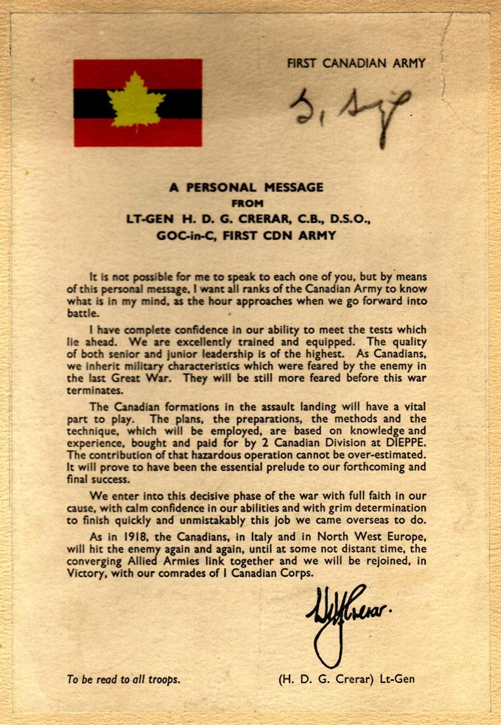

Your Task: Examine the inferences below and return to the text. Which sections or quotations would best support each inference?
 | Alternative Inferences
Person 1: | H.D.G. Crerar’s letter indicates his belief that Canadian troops are superior to the other allied troops involved in D-Day, and that is why they were tasked with landing at Juno Beach.
Which sections or quotations would best support this inference?

Person 2: | Recognizing the potential dangers of D-Day, the H.D.G. Crerar is trying to boost morale and give confidence to the troops before the challenging invasion.
Which sections or quotations would best support this inference?

G1: Inference - Cognitive Demand: that historians can draw different and even conflicting inferences from a source [Template]

Directions: After reading the background information and examining the source, answer the questions below.

Background Information: [Insert Contextual Information]

Featured Source:

Your Task: Examine the inferences below and return to the text. Which sections or quotations would best support each inference?

 | Inferences
Person 1: | [Insert inference]
Which sections/ quotations/aspects would best support this inference?

Person 2 | [Insert inference]
Which sections/ quotations/aspects would best support this inference?

G1: Inference - Cognitive Demand: Evaluates different inferences [Example]
Directions: After reading the background information and examining the source, answer the questions below.

Background Information: World War I Training
Prior to entering combat, Canadian and allied troops typically received their military training in Great Britain. The source below is a letter sent from Canadian Allan Hager to his sister on November 12th, 1915.

Directions: Use the following source to answer the questions below.
Dear Sister:

You'll excuse me if this letter is a wee bit short to-night. I only have a few minutes to spare, and I am very tired. I have had a very trying time these last two weeks. They have made a musketry instructor out of me. I don't know how long the job is going to last, but I hope it won't be long. It is no joke to get up in front of a bunch of men, and lecture them for six hours every day, and then take them to the ranges and have the responsibility of them shooting at the targets and watching to see that they don't shoot themselves. You would think there was not much to learn about handling a rifle but just a bunch of green men and put them at target shooting without any training and you would find a great many dead men before the day was out.

Source: Allan Hager (1915), Letter to His Sister

Your Task: Examine the inferences below and use two different coloured highlighters to note evidence which could be used to support each inference.

 | Alternative Inferences
Person 1: | The author of this letter found his role exhausting and stressful.
Person 2 | The author of this letter is does not enjoy his job and wants to quit the military.

Multiple Choice: Which inference is most plausible?
- Person 1’s inference is most plausible.
- Person 2’s inference is most plausible.
- Both Person 1 and Person 2’s inferences are equally plausible.
- Neither meaning is plausible.

Short Answer Response: Explain your reasoning below.
G1: Inference - Cognitive Demand: – Evaluates different inferences [Template]


Directions: After reading the background information and examining the source, answer the questions below.

Background Information: [Insert Contextual Information]

Featured Source:

Your Task: Examine the inferences below and return to the text. Which inference is best supported by the source?

 | Inferences
Person 1: | [Insert inference]
Person 2 | [Insert inference]

Multiple Choice: Which inference is most plausible?
- Person 1’s inference is most plausible
- Person 2’s inference is most plausible
- Both Person 1 and Person 2’s inferences are equally plausible
- Neither meaning is plausible

Short Answer Response: Explain your reasoning below.

G2: Questioning - Cognitive Demand: Understands the difference between an account and a trace

Directions: After reading the background information answer the questions below.

Background Information: One way of dividing historical sources is between traces and accounts. Traces are physical clues of the past such as artifacts, personal items, clothing, tools, or other records such as photographs, government documents, etc. Accounts on the other hand are a deliberate telling of what happened in the past. These can be in the form of newspaper articles, memoirs, interviews, letters, oral stories, or textbooks.

 | Source Description
Trace / Account | The Red Ensign flag, Canada's national flag from 1868 to 1965.
Trace / Account | An article on the internet describing how the Fur Trade impacted indigenous peoples in North America
Trace / Account | Indigenous peoples, particular those of the Northeastern Woodlands describe how earth was created on the back of a turtle.
Trace / Account | A Hudson’s Bay Blanket featuring red, green, yellow, and typically indigo striped pattern. The blanket and others like it were often traded during the Fur Trade in early Canada.

G2: Questioning - Cognitive Demand: Understands the difference between an account and a trace

Directions: After reading the background information answer the questions below.

Background Information: One way of dividing historical sources is between traces and accounts. Traces are physical clues of the past such as artifacts, personal items, clothing, tools, or other records such as photographs, government documents, etc. Accounts on the other hand are a deliberate telling of what happened in the past. These can be in the form of newspaper articles, memoirs, interviews, letters, oral stories, or textbooks.

 | Source Description
Trace / Account | [Insert Source Description]
Trace / Account | [Insert Source Description]
Trace / Account | [Insert Source Description]
Trace / Account | [Insert Source Description]

G2: Questioning - Cognitive Demand: Understands the difference between factual-recall questions, and open-ended inquiry questions

Directions: After reading the background information, sort the questions according to the categories provided.

Background Information: Historians ask good questions about what happened in the past. The best kind of questions, the most interesting, engaging, and useful, are those that ask us to make a judgment when we answer them. Rather than factual recall questions about facts, dates, and names, historical inquiry questions are open-ended, and require the use of evidence to support a reasoned conclusion. Compare the two following examples:
- Factual Recall Question: What year did World War I begin?
  - This question has a simple, factual answer: 1914. It does not require interpretation, analysis, or use of evidence beyond recalling the date.
- Historical Inquiry Question: Was World War I inevitable?
  - This open-ended question requires an examination of the complex causes of World War I such as alliances, militarism, imperialism, nationalism. The way the question is framed will require working with historical evidence to make a reasoned judgements about the relative impacts of each contributing cause.

Question | Effective or Not Effective? | Reasoning
To what extent did Canada’s contributions to WWI affect the outcome of the war? | - Effective  - Not Effective
During which year did Canada make the greatest impact on WWI? | - Effective  - Not Effective
Who was the Canadian General who lead the allied soldiers to a dramatic victory at Vimy Ridge? | - Effective  - Not Effective
How many Canadian soldiers participated in The Battle of Ypres and Vimy Ridge? | - Effective  - Not Effective
What were the most important short-term and long-term impacts of WWI for Canadian society? | - Effective  - Not Effective
G2: Questioning - Cognitive Demand: Understands the difference between factual-recall questions, and open-ended inquiry questions

Directions: After reading the background information, sort the questions according to the categories provide.

Background Information: Historians ask good questions about what happened in the past. The best kind of questions, the most interesting, engaging, and useful, are those that ask us to make a judgment when we answer them. Rather than factual recall questions about facts, dates, and names, historical inquiry questions are open-ended, and ask you to weight the influences of different causes, the significance of consequences, the importance of people and issues. Compare the two following examples:

- Factual Recall Question: When did the last Indian Residential School in Canada close?
- Historical Inquiry Question: What have been the greatest long term impacts of the Indian Residential School System in Canada?

Knowing when the last Indian Residential School closed is important information to know, but it is less likely to generate an open-ended inquiry in the way that the latter question would.

Question | Effective or Not Effective? | Reasoning
[Insert Recall/Open-Ended Question] | - Effective  - Not Effective
[Insert Recall/Open-Ended Question] | - Effective  - Not Effective
[Insert Recall/Open-Ended Question] | - Effective  - Not Effective
[Insert Recall/Open-Ended Question] | - Effective  - Not Effective
[Insert Recall/Open-Ended Question] | - Effective  - Not Effective
G2: Questioning - Cognitive Demand: Evaluates the suitability of questions about traces and accounts

Directions: After reading the background information and examining the source, answer the questions below.

Background Information: Within months of the outbreak of World War I in 1914, intricate series of defensive trenches were constructed along the Western Front, particularly in France and Belgium.
Featured Source:

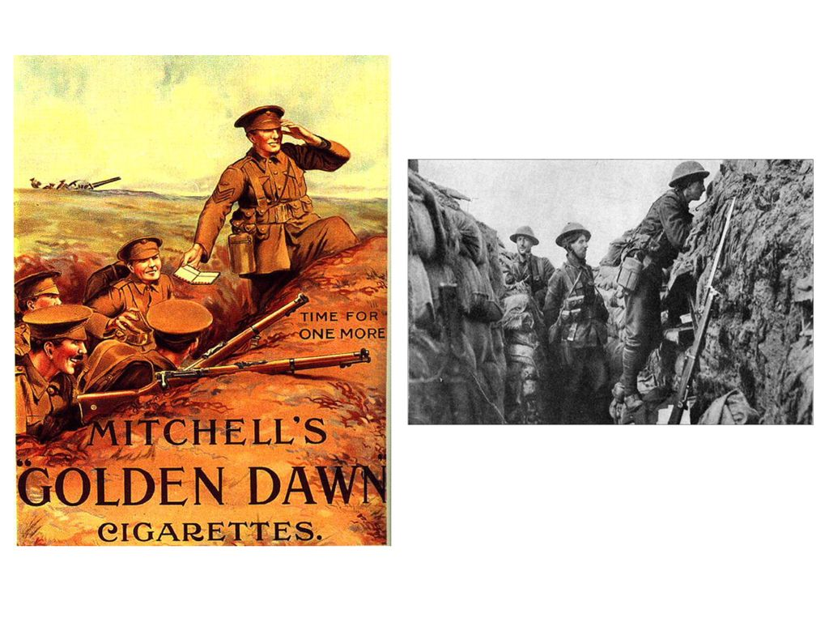

Title: Time for One More
Artist: Mitchell’s “Golden Dawn” Cigarettes
Date: 1914-1918

Which of the following questions would the source below best help to answer? [Circle Two]
- What was trench warfare like for soldiers in WWI?
- How were soldiers used to market products during WWI?
- How bad are cigarettes for human health?
- What were soldiers preferred brand of cigarettes?
- How does the creator of this image use colour to create a mood?

Explain your reasoning:
G2: Questioning - Cognitive Demand: Evaluates the suitability of questions about traces and accounts

Directions: After reading the background information and examining the source, answer the questions below.

Background Information: Within months of the outbreak of World War I in 1914, intricate series of defensive trenches were constructed along the Western Front, particularly in France and Belgium.
Featured Source:

Which of the following questions would the source below best help to answer? [Circle Two]
- [Insert Question]
- [Insert Question]
- [Insert Question]
- [Insert Question]

Explain your reasoning:

G2: Questioning - Cognitive Demand: Evaluates the suitability of questions about traces and accounts

Directions: After reading the background information and examining the source, answer the questions below.

The Titanic Deck Chair: The Titanic was a British passenger liner that tragically sank on its maiden voyage in 1912 after colliding with an iceberg in the North Atlantic Ocean. Over 1,500 passengers died, and the event has become one of the most famous maritime disasters in history. The image below shows a deck chair from the Titanic which is displayed in the Halifax Maritime Museum’s exhibit “Titanic: The Unsinkable Ship and Halifax”.

Featured Source:

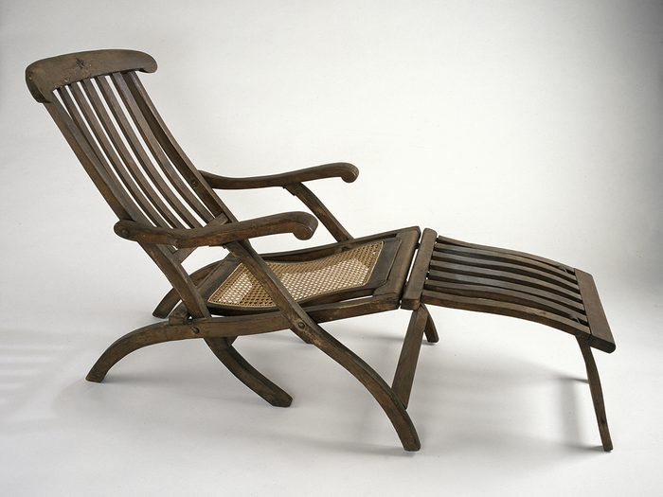

Several students were asked to contribute an open-ended inquiry question inspired by the source above. Which student suggestion is best [Circle One]
- Student A: How might creator of this source be biased?
- Student B: How is this source symbolic of early 20th century optimism?
- Student C: What kind of wood is this chair made of?
- Student D: What other evidence would be needed to corroborate this source?

Explain your reasoning.

G2: Questioning - Cognitive Demand: Evaluates the suitability of questions about traces and accounts

Directions: After reading the background information and examining the source, answer the questions below.

Background Information: [Insert Contextual Information]

Featured Source:

Several students were asked to contribute an open-ended inquiry question inspired by the source above. Which student suggestion is best [Circle One]
- [Insert Question]
- [Insert Question]
- [Insert Question]
- Insert Question]

Explain your reasoning.

G2: Questioning - Cognitive Demand: Generates relevant historical inquiry questions from a source
Directions: After reading the background information and examining the source, answer the question below.

Background Information: The Statute of Westminster, passed in 1931, was a key moment in the evolution of Canadian Government. The Statute allowed Canada to make and change laws without requiring British Approval.

Featured Source:

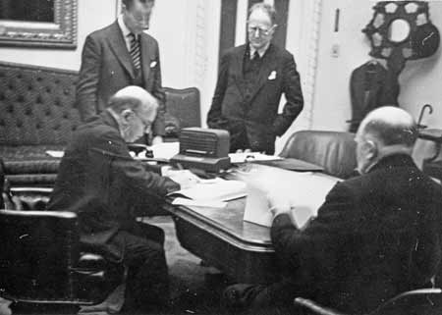

Short Answer Response: Using the featured source as your starting point, Generate an open-ended inquiry related to the Statute of Westminster. Consider reflecting on how the Statue of Westminster could be analyzed through the lens of Historical Significance, Continuity & Change, Historical Perspectives or other Historical Thinking Benchmarks.

G2: Questioning - Cognitive Demand: Generates relevant historical inquiry questions from a source
Directions: After reading the background information and examining the source, answer the question below.

Background Information: [Insert Contextual Information]

Featured Source:

Short Answer Response: Using the featured source as your starting point, Generate an open-ended inquiry related to the [insert description of featured source] Consider reflecting on how the [insert featured source] could be analyzed through the lens of Historical Significance, Continuity & Change, Historical Perspectives or other Historical Thinking Benchmarks.

G3: Sourcing - Cognitive Demand: Knows what sourcing is


Directions: The text below describes how historians source traces and accounts of the past. After reading the passage, answer the questions below.
Sourcing is an important part of historical research and begins even before a historian actually reads or views a historical trace or account. Sourcing is the process through which a historian assesses whether a source might be useful in helping them answer a particular question they are asking.

Before reading or viewing a source, a historian determines whether it is a primary source or a secondary source, typically by identifying the date when the source was created. Primary sources are firsthand accounts or original materials from the time period being studied while secondary sources are interpretations or narratives based on primary sources created at a later date.

Historians then ask who created this source, what was their relation to the event, theme or person in question, what type of source is it (letter, speech, artifact), and how might that influence the information presented? Why was this source created?

By answering these questions, historians can determine the strengths and limitations of a source which will influence whether they use it to support a historical argument or narrative.

- What does "sourcing" mean in the context of historical research?
  - The process of finding old artifacts and relics.
  - The identification and evaluation of historical sources.
  - The creation of stories based on historical events.
  - The memorization of historical dates and facts.

- Why is sourcing important in historical research?
  - It helps historians memorize more information about the past.
  - It helps historians create arguments and narratives without any evidence.
  - It helps historians judge the usefulness of a source for their research.
  - It helps historians avoid using primary sources.

- What is not an example of an effective sourcing question?
  - Does this source provide reliable evidence?
  - Is this source relevant to the question being asked?
  - Is this an authentic source or is it a forgery?
  - What would this author say their experience today?

Sourcing - Cognitive Demand: Identifies source metadata [Example]

Directions: After reading the background information and examining the source, answer the questions below.

Background Information: During World War I, Prime Minister Sir Robert Borden introduced the War Measures Act in 1914 giving the Canadian government broad powers to respond to perceived threats to national security [the safety of the country]. Thousands of people of Ukrainian, German, and other Central European background were labelled “enemy aliens” and placed in internment camps. William Dillon Otter oversaw the internment operations, while various military officials and local authorities were involved in the establishment and management of the camps. The camps were closed in 1920, two years following the end of the war.
- This source is a
  - Primary source
  - Secondary source
  - Neither a primary nor secondary source
  - Textbook
- The author of the source is:
  - Robert Borden
  - G. Willrich
  - William Otter Dillon
  - General Hague

- The source was created in…
  - 1916
  - 1907
  - 1914
  - 1920
Featured Source:

The prisoners in Canadian Internment Camps came to the Dominion [of Canada] as peaceful emigrants and the great majority of them at least have been good, law abiding residents …. In other words, these men now held as prisoners … are good, sturdy, inoffensive men, able and willing to work, most of them desirous of becoming [wanting to become] Canadian citizens. .... There is no doubt in my mind, that at the present moment, the great majority of the prisoners....could safely be returned to their homes and families, and that such return would be more profitable [valuable] to Canada in the end...

Source: Willrich, G. US Consul, Quebec City, 16-21 November 1916. G. Willrich reported on the conditions in Canadian internment camp, as neutral governments were permitted to inspect the treatment of prisoners of war being held in enemy camps due to the 1907 Hague Convention.

Sourcing - Cognitive Demand: Identifies source metadata [Template]
Directions: After reading the background information and source, answer the questions below.

Background Information: [Insert Contextual Information]

[Insert Source]

Source: [Insert Source Information

- The author/creator of this source is…

- The source was created in…

Sourcing - Cognitive Demand: Identifies relevant background information [Example]

Directions: After reading the background information and source, answer the questions below.

Trudeau on the Meech Lake Accord

Pierre Trudeau, born on October 18, 1919, in Montreal, Quebec, emerged as a prominent figure in Canadian politics during the latter half of the 20th century. He was known for his dynamic personality, with his charm and charisma often captivating the public and media.  He was also particularly known for his love of outdoor activities, including canoeing, skiing, and boxing.  As the 15th Prime Minister of Canada, serving from 1968 to 1979 and again from 1980 to 1984, Trudeau had a significant impact on French-English relations in the country. He was a strong supporter of bilingualism and multiculturalism, seeking to promote a stronger sense of national unity among Canadians, regardless of their linguistic or cultural backgrounds.  Trudeau's implementation of the Official Languages Act in 1969 made Canada an officially bilingual nation.

“The real question to be asked is whether the French Canadians living in Quebec need a provincial government with more powers than the other provinces. I believe it is insulting to us to claim that we do. The new generation of business executives, scientists, writers, filmmakers, and artists of every description has no use for the siege mentality [feeling defensive, or like a victim] in which the elites of bygone days used to cower [hide in fear]. The members of this new generation know that the true opportunities of the future extend beyond the boundaries of Quebec, indeed beyond the boundaries of Canada itself. They don’t suffer from any inferiority complex [feeling inadequate or less than], and they say good riddance [goodbye] to the times when we didn’t dare to measure ourselves against “others” without fear or trembling. In short, they need no crutches.”

Source: Pierre Elliott Trudeau, “Say Goodbye to the Dream of One Canada”, Toronto Star & [Montreal] La Presse (27 May 1987).

Multiple Choice: Which section of the background information provides the least relevant contextual information to inform your response to the following question: “How does Pierre Trudeau’s speech ‘Say Goodbye to the Dream of One Canada’ reveal his attitude towards French-English relations in Canada between 1968-1984?” (Circle One)
- Section 1
- Section 2
- Section 3
- Section 4

Short Answer Response: Explain your reasoning:

Section ____ is less relevant because…

Sourcing - Cognitive Demand: Identifies relevant background information [Template]

Directions: After reading the background information and source, answer the questions below.

Background Information: [Insert contextual Information] [Insert contextual Information] [Insert contextual Information] [Insert contextual Information]

[Insert Source]

Source: [Insert Source Metadata]

Multiple Choice: Which section of the background information provides the least relevant contextual information to inform your response to the following question: “[Insert inquiry question]”

- Section 1
- Section 2
- Section 3
- Section 4

Sourcing - Cognitive Demand: Explains the strengths and limitations of a source based upon its metadata [Example – Digital Inquiry Group]

Directions: After reading the background information and examining the source, answer the questions below.

Background information: Samuel de Champlain was a French explorer who played a significant role in the early exploration and colonization of Canada. He founded the city of Quebec in 1608 and established enduring French influence in the region. In 1609, Samuel de Champlain joined Algonquin, Wendat (Huron) and Innu (Montagnais) allies in a battle against the Iroquois near Ticonderoga.
Featured Source:

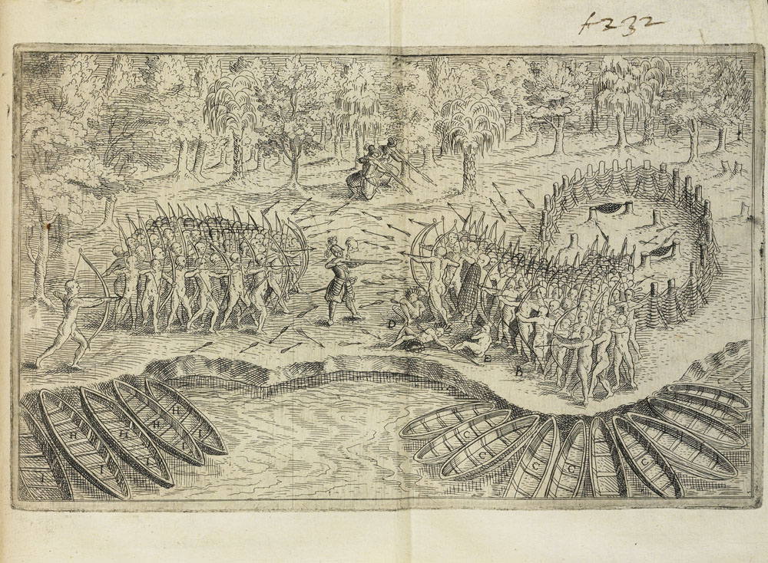

Source: Champlain, Samuel de. “Deffaite des Yroquois au Lac de Champlain” / “Defeat of the Iroquois at Lake Champlain” published in Champlain, S. de, Les voyages du sieur de Champlain.. / Champlain’s Voyages (1613)

Question 1: Why might this source be useful as evidence of what happened during the battle at Ticonderoga/Lake Champlain?

This source is useful because…

Question 2: What about this source might make it less useful as evidence of what happened during the battle at Ticonderoga/Lake Champlain?

This source is less useful because…
Sourcing - Cognitive Demand: Explains the strengths and limitations of a source based upon its metadata [Template - Digital Inquiry Group]
Directions: Use the image, background information, and source information to answer the questions that follow.

Background Information: [Insert Contextual Information]

[Insert Source]

Source: [Insert Source Metadata]

Question 1: Why might this source be useful as evidence of what happened during….

This source is useful because…

Question 2: What about this source might make it less useful as evidence of what happened during…

This source is less useful because…

Sourcing - Cognitive Demand: Explains the strengths and limitations of a source based upon its metadata [Example - Digital Inquiry Group]
Directions: After reading the background information and examining the source, answer the questions below.

Background Information: On his second voyage to North America in 1535, Jacques Cartier was led to the Iroquois settlement of Stadacona by Domagaya and Taignoagy, sons of Donnaccona, the leader of the community. Domagaya and Taignoagy had been seized and taken to France following Cartier’s previous trip to the area in 1534.
Featured Source:
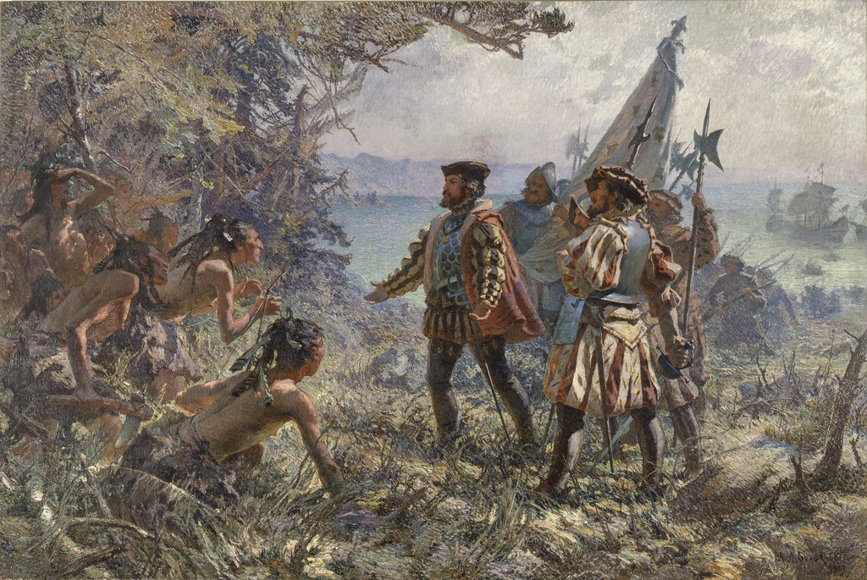

Title: Jacques Cartier Meeting the Indians at Stadacona, 1535
Artist: Marc-Aurèle de Foy Suzor-Coté
Date: 1907

Statement: The painting “Jacques Cartier Meeting the Indians at Stadacona, 1535” helps historians understand the circumstances of the meeting Cartier and the Iroquois at the community of Stadacona in 1535.

Do you agree or disagree? (Circle One)
Explain your reasoning:

Sourcing - Cognitive Demand: Explains the strengths and limitations of a source based upon its metadata [Template - Digital Inquiry Group]

Directions: Use the image, background information, and source information to answer the questions that follow.

Background Information: [Insert Contextual Information]
Featured Source:

Source: [Insert Source Metadata]

Statement: The painting “[Insert source title]” helps historians understand the [insert description of event]

Do you agree or disagree? (Circle One)
Explain your reasoning:

Sourcing - Cognitive Demand: Explains the strengths and limitations of a source based upon its metadata [Example – Digital Inquiry Group]

Directions: After reading the background information and examining the source, answer the questions below.

Featured Source:

“It was a ten hour work day. You worked Saturdays. And if you had to work on holidays you had no choice. There was no time-and-a-half that I recall, nobody got time-and-a-half. . . . You had no job security, you had no grievance procedure. They didn’t like you, they fired you. If you made a little mistake, you were out. If you got hurt – and God forbid you reported it – you were out. Workmen’s compensation existed but I don’t know if you were ever able to collect on it. Long hours and a long work week. Nobody to demand sanitary conditions or workloads. There was nothing.

And that’s what we accomplished. We accomplished workloads, union representation, . . . time-and-a-half, a five-day work week, work clothes, vacation pay – and of course later on was pension and group insurance – grievance procedure, no layoffs unless you had arbitration. My God, it was a new world.”

Additional facts related to Marianna Costa’s account:
- Although Marianna Costa is describing events in 1933, this interview was recorded in 1994.
- Paterson, New Jersey was home to several textile factories with thousands of workers.
- Costa became an elected union official, which was uncommon for women at the time.
- In 1933, women had only recently acquired the right to vote and had only voted in
four presidential elections.

Short Answer Response: Which 2 of the 4 facts above might cause you to question the reliability of Costa’s account?

Sourcing - Cognitive Demand: Explains the strengths and limitations of a source based upon its metadata [Template – Digital Inquiry Group]

Directions: After reading the background information and examining the source, answer the questions below.

Featured Source:

[Insert Source]

Additional facts related to Marianna Costa’s account:
- [Insert Additional Facts]
- [Insert Additional Facts]
- [Insert Additional Facts]
- [Insert Additional Facts]

Short Answer Response: Which 2 of the 4 facts above might cause you to question the reliability of _____________________ account?

Sourcing - Cognitive Demand: Explains the strengths and limitations of a source based upon its metadata [Example]

Directions: After reading the background information and examining the source, answer the questions below.

Background information: Samuel de Champlain was a French explorer who played a significant role in the early exploration and colonization of Canada. He founded the city of Quebec in 1608 and established enduring French influence in the region. In 1609, Samuel de Champlain joined Algonquin, Wendat (Huron) and Innu (Montagnais) allies in a battle against the Iroquois near Ticonderoga.

Featured Sources:
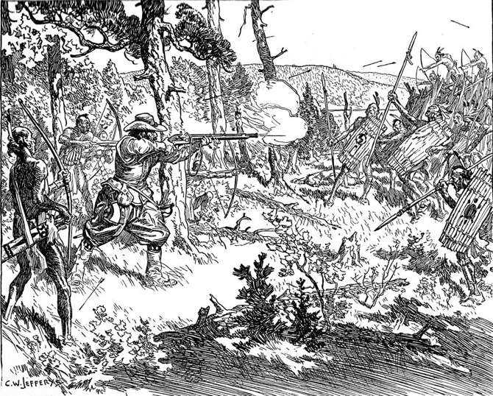  SOURCE A  Source: Jefferys, Charles, (1934 )“Champlain’s Fight with the Iroquois, 1609” | 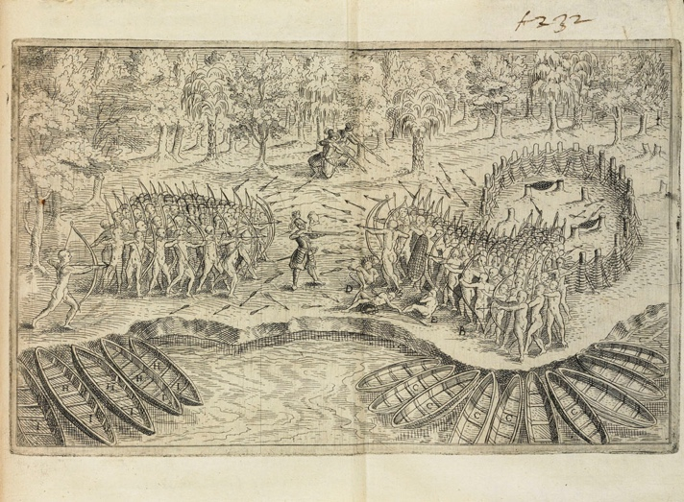  SOURCE B  Source: Champlain, Samuel de. “Defeat of the Iroquois at Lake Champlain” published in Champlain, S. de, Les voyages du sieur de Champlain.. / Champlain’s Voyages (1613)

Statement: Which source would be more useful as evidence regarding the battle between the Iroquois and the Alqonquin, Wendat, and Innu in 1609?

Explain your reasoning below:

Source ___ is more useful because…

Source ___ is less useful because…

Sourcing - Cognitive Demand: Explains the strengths and limitations of a source based upon its metadata [Template]

Directions: After reading the background information and examining the source, answer the questions below.

Background information: [insert contextual information]

Featured Sources:
SOURCE A  Source: | SOURCE B  Source:

Statement: Which source would be more useful as evidence regarding [insert event/issue here]

Explain your reasoning below:

Source ___ is more useful because…

Source ___ is less useful because…

Sourcing: Cognitive Demand 4 – Explains the strengths and limitations of a source based upon its metadata [Example]
Directions: After reading the background information and examining the sources, answer the questions below.
Trench Warfare
Within months of the outbreak of World War I in 1914, intricate series of defensive trenches were constructed along the Western Front, particularly in France and Belgium. Canadian soldiers participated in many battles until the war was ended in 1918.

Featured Sources:
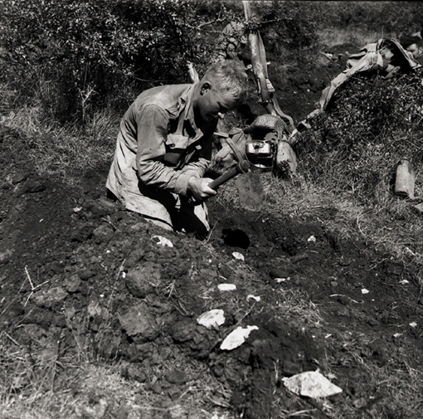  Title: Private Thomas Hawkins, Royal Canadian Regiment, digging slit trench near Motta, Italy, 3 October 1943.  Photographer: J.H. Smith  Date: 1943  SOURCE A | 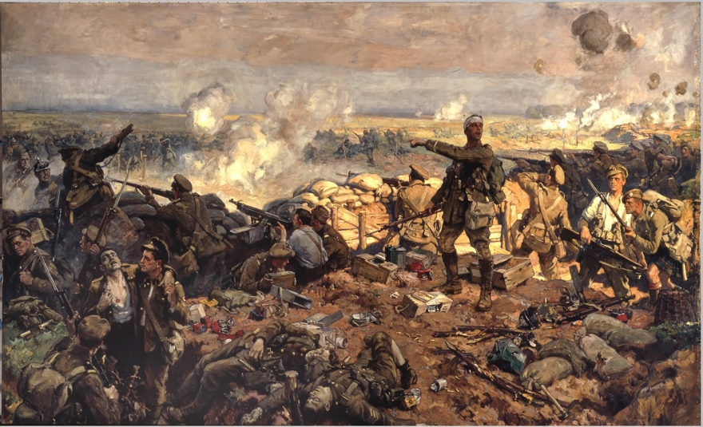  Title: The Second Battle of Ypres, 22 April to 25 May 1915  Artist: Richard Jack – Canadian War Artist commissioned by the Canadian War Records Office to document Canada’s participation in World War I. While not present at Ypres, Jack interviewed soldiers who had participated, and had some pose to recreate the scene of the battle.  Date: 1917  SOURCE B

Statement: Which source would be more useful if learning about the experience for Canadian soldiers during World War I?
Source A / Source B (Circle One)

Explain your reasoning: Source ___ is more/less useful because…

Sourcing: Cognitive Demand 4 – Explains the strengths and limitations of a source based upon its metadata [Example]
Directions: After reading the background information and examining the sources, answer the questions below.

Background Information: [Insert Contextual Information]

SOURCE B
SOURCE A

[Insert Source]

Source: [Insert source info]

[Insert Source]

Source: [Insert source info]

Statement: Which source would be most useful when inquiring about [insert inquiry question]?

Source A / Source B [Circle One]

Explain your reasoning: Source ___ is more/less useful because…

G3: Sourcing - Cognitive Demand: Explains the strengths and limitations of a source based upon its metadata.

Directions: Use the background information and source to answer the questions that follow.

Background Information: The Battle of the Plains of Abraham was fought between the British and French forces on September 13, 1759, during the Seven Years' War. Led by General Wolfe, the British defeated French forces on the day, marking an important turning point in the battle for control of North America.
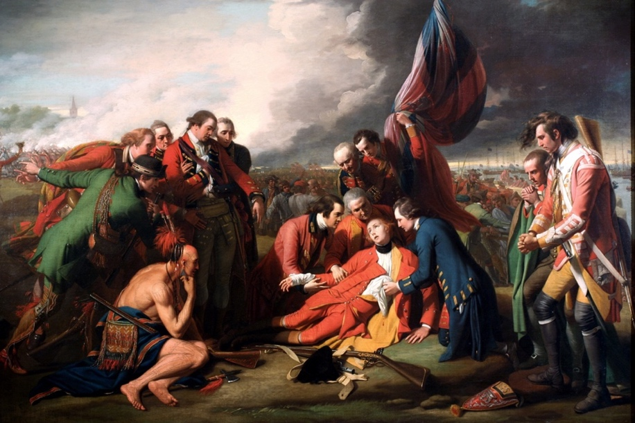
Title: The Death of General Wolfe
Artist: Benjamin West
Date: 1770

Statement 1: The painting “The Death of General Wolfe” is useful evidence to historians because it helps them understand how the event of General Wolfe's death was remembered and commemorated in the 18th century. | Agree / Disagree
Statement 2: The painting “The Death of General Wolfe” helps historians understand the circumstances of the death of General Wolfe during the Battle of the Plains of Abraham. | Agree / Disagree
Statement 3: The painting “The Death of General Wolfe” is useful evidence to historians because it helps them examine the artistic techniques, styles, and trends of the period, shedding light on the broader cultural context of the time. | Agree / Disagree

For the statement that you disagreed with, explain your reasoning:

I disagreed with Statement #___ because

Blank template

G3: Sourcing - Cognitive Demand: Explains the strengths and limitations of a source based upon its metadata.

Directions: After reading the background information and viewing the source, answer the questions below.

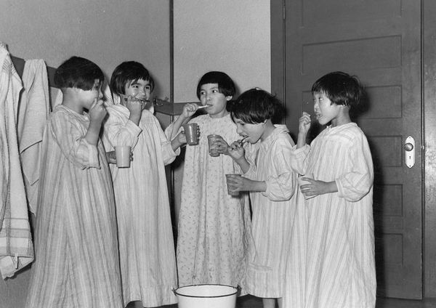
Background Information: The Canadian Indian Residential School System forcibly separated Indigenous children from their families and communities from the late 19th century to the late 20th century. The system aimed to assimilate indigenous peoples into Euro-Canadian culture, leading to the loss of language, culture, and widespread abuse, causing profound intergenerational trauma among Indigenous peoples.

Source: St. Philip’s Indian Residential School in Fort. George, Quebec in 1947/1948, The General Synod Archives, Anglican Church of Canada.

- What would be the most significant limitation of this sources as a source of information about life in the Canadian Indian Residential School System

  - The General Synod Archives of the Anglican Church of Canada were unable to provide an exact date, and so we only know approximately when it was taken, between 1947 and 1948.
  - It is likely a forgery as the use of dental care items such as toothpaste and toothbrushes only became common in the late 1950s, and so this photograph could not have been taken in 1947-1948
  - Due to the fact that colour photographs had not been invented, we are unable to see more fully what life was like in Indian Residential Schools at the time.
  - It was likely taken by an adult employee of St. Philip’s Indian Residential School and may intentionally be trying to portray life in residential schools as a positive experience.

- Explain your reasoning below:

blank

G4: Contextualization - Cognitive Demand: Knows What Contextualizing Is


Directions: The text below describes how historians contextualize traces and accounts of the past. After reading the passage, answer the questions below.
Contextualization helps historians understand the broader circumstances in which a historical event, source, or account was created. It involves situating a source within its historical context by considering the social, political, economic, and cultural conditions of the time.

When historians contextualize a source, they ask questions such as:

- What was happening at the time this source was created? What was happening from a global or national perspective, but also from perhaps a local or even personal perspective of the source’s creator.
- How might the events, beliefs, or conditions of that time shape the source's content?

By understanding the context in which a source was produced, historians can better interpret its meaning and significance.

- What does "contextualization" mean in the context of historical research?
  - The process of memorizing historical dates and figures.
  - Using background knowledge to better understand historical sources
  - The method of rewriting history based on modern perspectives.
  - Assessing whether or not sources agree or conflict with each other.
- Which of the following is NOT an example of an effective contextualization question?
  - What events were occurring when this source was created?
  - How do social and political conditions of the time influence this source?
  - Is this source a trace or account?
  - What likely motivated the author of this source to write it?

G4: Contextualization - Cognitive Demand: Connects source to, and recognizes influence of, broader historical contexts on the content of a source

Directions: After reading the background information and examining the source, answer the questions below.

Background Information: In 1837 and 1838, Lower and Upper Canada experienced multiple uprisings against the government.

Source A: Speech from William Lyon Mackenzie, leader of the Upper Canada Rebellion  BRAVE CANADIANS! God has put into the bold and honest hearts of our brethren in Lower Canada to revolt - not against “lawful” but against “unlawful" authority. The law says we shall not be taxed without our consent by the voices of the men of our choice, but a wicked and tyrannical government has trampled upon that law - robbed the exchequer - divided the plunder - and declared that, regardless of justice they will continue to roll their splendid carriages, and riot in their palaces, at our expense - that we are poor spiritless ignorant peasants, who were born to toil for our betters. But the peasants are beginning to open their eyes and to feel their strength…  CANADIANS! Do you love freedom? I know you do. Do you hate oppression? Who dare deny it?... Then buckle on your armor, and put down the villains who oppress and enslave our country. . . . | Consent: Agreement  Men of our choice: Democratically elected representatives  Tyrannical: Oppressive / Undemocratic  Exchequer: Treasury  Plunder: Loot / Wealth gained by stealing  Toil: Work

Source B: Excerpt from “The Durham Report”, titled Report on the Affairs of British North America”  “I expected to find a contrast between a government and a people: I found two nations warring in the bosom of a single state: I found a struggle, not of principles, but of races; and I perceived that it would be idle to attempt any amelioration of laws or institutions, until we could first succeed in terminating the deadly animosity that now separates the inhabitants of Lower Canada into the hostile divisions of French and English.” | Bosom: Heart  Amelioration: Improvement  Terminating: Ending  Animosity: Hatred

Short Answer Response:
Letter ____ was likely written first because…

Letter ____ was likely written first because

Contextualization - Cognitive Demand: Connects source to, and recognizes influence of, broader historical contexts on the content of a source [Template]

Directions: After reading the background information and examining the source, answer the questions below.

Background Information: [insert background information]

Source A:

Source B:

Short Answer Response:

Letter ____ was likely written first because…

Letter ____ was likely written first because…

Contextualization - Cognitive Demand: Connects source to, and recognizes influence of, broader historical contexts on the content of a source [Example – To The Past]

Directions: After reading the background information and examining the source, answer the questions below.

Background Information: Canada officially joined World War II on September 10, 1939, seven days after the United Kingdom and France declared war on Germany. troops were mobilized, and the entire population was encouraged to support the war effort by increasing production, rationing key resources, and supporting the government through the buying of Victory Bonds. In contrast, The United States joined World War II two years later, December 7, 1941, following the Japanese attack on Pearl Harbor.
Featured Source:
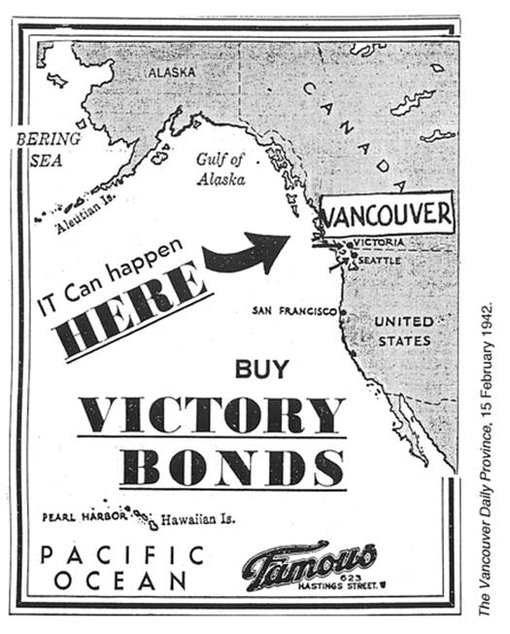
Source:
Question: The above advertisement for Victory Bonds was most likely published in what year?
- 1918
- 1939
- 1940
- 1942

Short Answer Response: Explain your reasoning below.

Contextualization - Cognitive Demand: Connects source to, and recognizes influence of, broader historical contexts on the content of a source [Template]

Directions: After reading the background information and examining the source, answer the questions below.

Background Information: [Insert Contextual Information]

Featured Source:

Question: The featured source was most likely published in what year?

Short Answer Response: Explain your reasoning below.

Corroboration - Cognitive Demand: Understands the difference between contrary, conflicting, complimentary, and corroborating primary sources
Directions: The text below describes the relationships that different sources can have with one another. Navigating contradictory, contrary, complimentary and corroborating evidence can be both a source of frustration and fascination for historians. Through the process of identifying how evidence fits together, historians gain a clearer picture of the past. After reading the text answer the questions below to check your understanding.
The sources are contradictory/conflicting: The sources provide completely opposite information or viewpoints about an event, making it difficult to determine what actually happened.
- Example: One source says that a historical leader was loved by the people, while another claims the leader was despised and faced frequent rebellions.
The sources are contrary: While there are differences in perspective, the difference is in emphasis or minor details.
- Example: One source mentions that a battle took place in late summer, while another describes it happening in the fall. The sources don’t fully agree on the exact season, but overall mention similar overall details.
The sources are complimentary: The sources provide different details or perspectives that add to each other, helping to create a fuller picture of an event.
- Example: One source describes the strategy used in a battle, while another source discusses the supplies and logistics. Together, they complement each other by giving a more complete understanding of the battle.
The sources are corroborating: The sources agree with each other on major points, providing evidence that supports the same information or viewpoint, which increases confidence in its accuracy.
- Example: Two separate eyewitness accounts both describe a historical protest as peaceful. Since they corroborate each other, historians can be more confident that the protest was, indeed, likely peaceful.

- One diary claims that a royal coronation was a joyful celebration attended by thousands, while another diary from the same time describes widespread protests and riots at the event. How would you classify these sources?
  - Contradictory
  - Contrary
  - Complimentary
  - Corroborating
- Source A states that a historical treaty was signed in a coastal city, while Source B says it was signed in the capital. Both agree on the year and the key terms of the treaty. How would you classify these sources?
  - Contradictory
  - Contrary
  - Complimentary
  - Corroborating
- A painting from the Renaissance era depicts a battle scene in vivid detail, while a written account from the same time describes the political consequences of the battle. How would you classify these sources?
  - Contradictory
  - Contrary
  - Complimentary
  - Corroborating

- Two court records from different towns both describe a 16th-century trial where the same defendant was accused of stealing livestock. Both records provide identical dates, charges, and outcomes. How would you classify these sources?
  - Contradictory
  - Contrary
  - Complimentary
  - Corroborating

Corroboration - Cognitive Demand: Understands the difference between contrary, conflicting, complimentary, and corroborating primary sources

Directions: After reading the featured text, answer the questions below to check your understanding.

When historians conduct research, they encounter many primary and secondary sources that inform their understanding of a past event, period or person. Historians regularly attempt to corroborate information they encounter in sources. This means they look for evidence from multiple sources that agree on key details, which helps them confirm that the information is reliable.

However, not all sources tell the same story. Historians often encounter conflicting accounts, where sources disagree or present completely opposite perspectives. In such cases, they must carefully analyze the context, purpose, and reliability of each source to determine which is more trustworthy. By cross-referencing and weighing evidence, historians piece together a more accurate and balanced understanding of the past, even when the evidence is incomplete or contradictory.

- The sources are contradictory: The sources provide completely opposite information or viewpoints about an event, making it difficult to determine what actually happened. It’s like if one friend says their team won 3-0, but another says they lost 2-1. These stories don’t match, so you’d need more information or other sources to find out the truth.
- The sources are corroborating: The sources agree with each other on major points, providing evidence that supports the same information or viewpoint, which increases confidence in its accuracy. Corroboration in history is like double-checking information to make sure it's accurate. By doing this, historians can be more confident that what they're saying about the past is true.

- One diary claims that a royal coronation was a joyful celebration attended by thousands, while another diary from the same time describes widespread protests and riots at the event. How would you classify these sources?
  - Contradictory
  - Corroborating

- Two court records from different towns both describe a 16th-century trial where the same defendant was accused of stealing livestock. Both records provide identical dates, charges, and outcomes. How would you classify these sources?
  - Contradictory
  - Corroborating

Corroboration - Cognitive Demand: Identifies when sources are contrary, conflicting, complimentary or corroborating. [Example]

Directions: After reading the background information and examining the source, answer the questions below.

Background Information: Over 100,000 Canadian troops were assigned to the region of Passchendaele in 1917. Canadians eventually took the ridge that had been long-held by the Germans, but at the cost of nearly 16,000 lives.

Featured Source:  The weather changed for the worse last night, although fortunately too late to hamper the execution of our plans. The rain was heavy and constant throughout the night. It was still beating down steadily when the day broke chill and cheerless, with a thick blanket of mist completely shutting off the battlefield. During the morning it slackened to a dismal drizzle, but by this time the roads, fields, and footways were covered with semi-liquid mud, and the torn ground beyond Ypres had become in places a horrible quagmire.  Source: Percival Phillips described the Battle of Passchendaele in the Daily Express (2nd August, 1917) | Hamper: Hinder/Prevent  Slackened: Lessened  Quagmire: Bog/Swamp

Featured Source:  Floods of rain and a blanket of mist have doused and cloaked the whole of the Flanders plain. The newest shell-holes, already half-filled with soakage, are now flooded to the brim. The rain has so fouled this low, stoneless ground, spoiled of all natural drainage by shell-fire, that we experienced the double value of the early work, for today moving heavy material was extremely difficult and the men could scarcely walk in full equipment, much less dig. Every man was soaked through and was standing or sleeping in a marsh. It was a work of energy to keep a rifle in a state fit to use. | Spoiled: Hinder/Prevent

Multiple Choice: What best describes the relationship between the two featured sources?
- The sources are contradictory
- The sources are contrary
- The sources are complimentary
- The sources are corroborating

Short Answer Response: Explain your reasoning below.

Corroboration - Cognitive Demand: Identifies when sources are contrary, conflicting, complimentary or corroborating. [Template]

Directions: After reading the background information and examining the source, answer the questions below.

Background Information: [Insert Contextual Information]

Featured Source:

Source:

Featured Source:

Multiple Choice: What best describes the relationship between the two featured sources?
- The sources are contradictory
- The sources are contrary
- The sources are complimentary
- The sources are corroborating

Short Answer Response: Explain your reasoning below.

